Smart Disaster Relief Inventory and Distribution Management System
A C Programming Mini-Project Report
PRESENTED BY
N.SANJANA(192412478)
JANAKI(192412409)
SYED NAZMA(192425193)

1. Problem Statement
Natural disasters such as floods, cyclones, and earthquakes create an urgent need to track and distribute limited essential resources — food, drinking water, medicines, blankets, rescue equipment, and temporary shelters — across multiple relief centres. Manual tracking is error prone and slow, often leading to some centres holding surplus stock while others face critical shortages. This project designs and implements a menu-driven C application that lets disaster management authorities add, update, search, sort, merge, analyse, and permanently store relief-resource records, and that automatically flags resources nearing or already in shortage.
2. Objective
- To design a modular C program that models a relief resource using a struct (ID, name, category, quantity, minimum required quantity, distribution centre, priority).
- To apply decision-making and looping constructs to validate input and to classify stock levels.
- To implement searching (linear and recursive binary search), multiple sorting techniques (by quantity, priority, category, ID), and duplicate-safe merging of records from different relief centres.
- To demonstrate recursion for centre-wise aggregation of resource quantities and pointers for direct-reference search and array traversal.
- To use file handling for permanent storage/retrieval of records and for generating a consolidated disaster-resource report.
- To map the solution to SDG 1 (No Poverty), SDG 2 (Zero Hunger), and SDG 11 (Sustainable Cities and Communities) by improving the efficiency and fairness of relief distribution.

3.Requirements and Environment Used
Category | Details
Language | C (Standard C99)
Compiler | GCC (any C99-compliant compiler: GCC / MinGW / Turbo C++ / Code::Blocks work)
Compile command | gcc -std=c99 -Wall -Wextra -o relief_system relief_system.c
Run command | ./relief_system (Linux/Mac) or relief_system.exe (Windows)
Header files used | stdio.h, stdlib.h, string.h, ctype.h
Storage | Plain text files (relief_data.txt, centre_b_data.txt, relief_report.txt) created in the working directory
Hardware | Any standard PC / laptop (no special hardware required)

4. Design / Proposed Solution
Core data structure
typedef struct {
int id;
char name[50];
char category[30];
int quantity;
int minRequired;
char centre[30];
int priority; /* 1-High, 2-Medium, 3-Low */
} Resource;
All records are held in a fixed-size array Resource inventory[MAX_RESOURCES] in main(), which is passed to every module function by array/pointer — keeping the design modular and avoiding global state.
Hardware Requirements
- Computer/Laptop
- Minimum 4 GB RAM
- Minimum 1 GB free storage
- Keyboard and monitor
Software Requirements
- Programming Language: C
- Compiler: GCC / MinGW / Turbo C-compatible compiler
- Operating System: Windows/Linux
- IDE: Visual Studio Code / Code::Blocks / Dev-C++ / Online C Compiler
Programming Concepts
- Operators
- Decision-making statements
- Loops
- Arrays
- Strings
- Structures
- Functions
- Pointers
- Recursion
- Searching
- Sorting
- Merging
- File handling

4. Design / Proposed Solution
The proposed system consists of several modules that work together to manage disaster-relief resources.
SYSTEM ARCHITECTURE
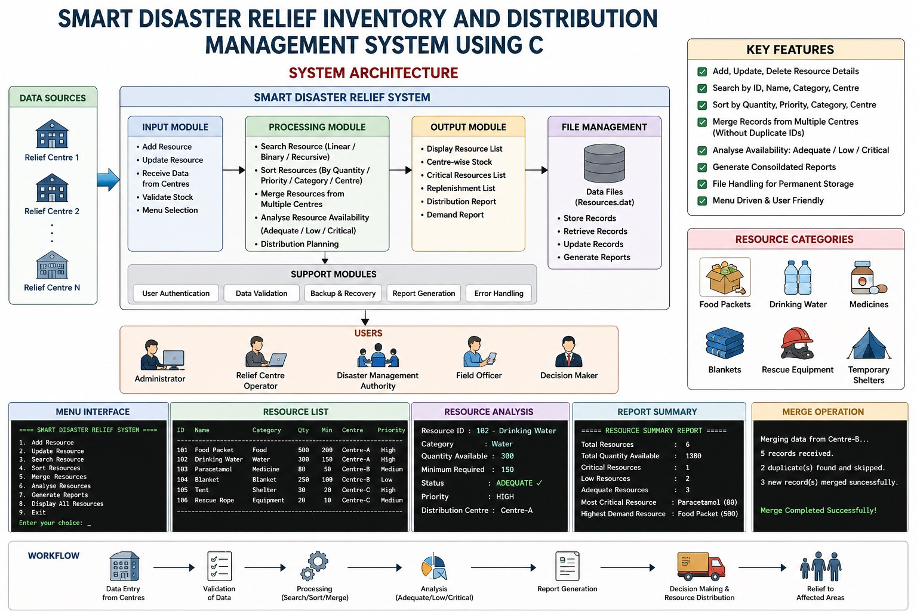

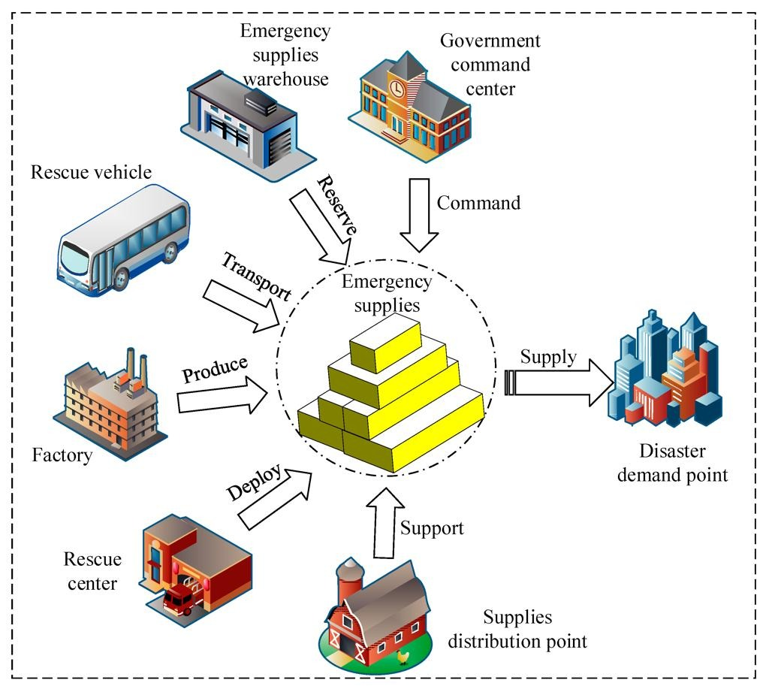
Resource Record
Each resource contains:
Resource ID
Resource Name
Category
Quantity Available
Minimum Required Quantity
Distribution Centre
Priority Level
Stock Classification
Condition | Status
Quantity > Minimum Required | Adequate
Quantity close to Minimum | Low
Quantity below critical threshold | Critical

5. Algorithm / Pseudocode / Flowchart
Algorithm
Step 1
Start the application.
Step 2
Display the main menu.
Step 3
Allow the administrator to select an operation:
- Add Resource
- Update Resource
- Search Resource
- Sort Resources
- Merge Records
- Analyse Resources
- Generate Report
- Save Records
- Load Records
- Exit
Step 4
For adding a resource, accept all required resource details.
Step 5
Validate the entered quantity, priority, and Resource ID.
Step 6
For searching, compare the requested value with stored records.
Step 7
For sorting, arrange records according to the selected criterion.
Step 8
For merging, compare Resource IDs and add only non-duplicate records.
Step 9
Analyse available quantity against the minimum required quantity.
Step 10
Classify resources as Adequate, Low, or Critical.
Step 11
Generate a consolidated report.
Step 12
Save records into a file.
Step 13
Continue until the administrator selects Exit.
Step 14
Stop.

Simple Flowchart
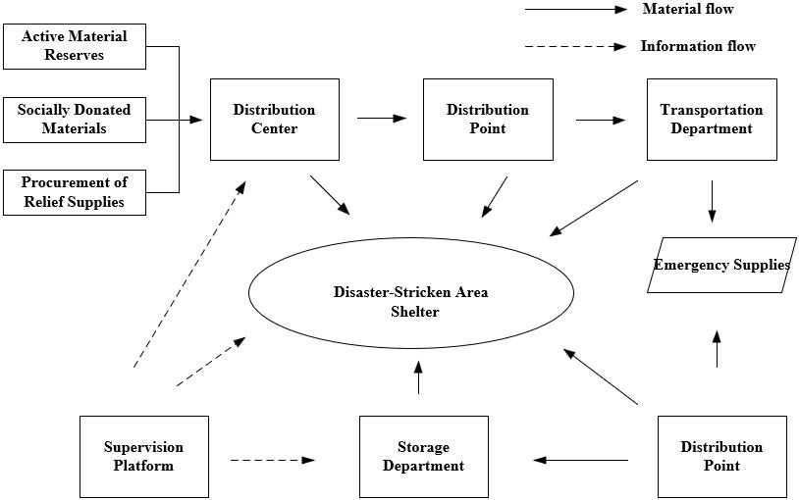
6. Implementation / Source Code
The implementation can be divided into the following functions:
addResource();
updateResource();
searchResource();
sortResource();
mergeResources();
analyseResources();
generateReport();
saveToFile();
loadFromFile();
Structure Used
struct Resource {
int id;
char name[50];
char category[30];
int quantity;
int minimum;
char centre[50];
int priority;
};
Major C Concepts
- Structure: Stores complete resource information.
- Array: Stores multiple resource records.
- Pointer: Allows direct modification of records.
- Function: Separates each operation into modules.
- Recursion: Can be used for recursive searching or analysis.
- File handling: Stores records permanently.
- Loops: Used for menu operations and record processing.
- Conditions: Used for stock classification and validation.

7. Test Cases and Expected/Actual Results
Test Case | Input / Operation | Expected Result
TC01 | Add Food, Quantity = 500 | Resource added successfully
TC02 | Search Resource ID = 101 | Correct resource displayed
TC03 | Quantity = 50, Minimum = 100 | Resource classified as Critical/Low
TC04 | Sort by Quantity | Records arranged by quantity
TC05 | Sort by Priority | Highest priority resources displayed first
TC06 | Search invalid ID | “Resource not found”
TC07 | Merge duplicate ID | Duplicate record rejected
TC08 | Merge new resource | New record added
TC09 | Save resources | Records stored in file
TC10 | Load resources | Previously stored records displayed
TC11 | Generate report | Consolidated report generated
TC12 | Invalid quantity | Input rejected
Example Test
Initial Quantity = 80
Minimum Required = 100

Result:
Status = CRITICAL
Action = Immediate Replenishment Required

8. Execution Screenshots / Output
You can include screenshots of the following outputs in your PPT/report:
Screenshot 1 – Main Menu
========================================
SMART DISASTER RELIEF INVENTORY SYSTEM
========================================

1. Add Resource
2. Update Resource
3. Search Resource
4. Sort Resources
5. Merge Records
6. Analyse Resources
7. Generate Report
8. Save Records
9. Load Records
0. Exit

Enter your choice:
Screenshot 2 – Resource Entry
Enter Resource ID : 101
Enter Resource Name : Food Packets
Enter Category : Food
Enter Quantity : 500
Enter Minimum Required : 300
Enter Distribution Centre: Centre A
Enter Priority : 1

Resource added successfully!
Screenshot 3 – Resource Analysis
RESOURCE ANALYSIS
--------------------------------
Food Packets 500 ADEQUATE
Water 250 LOW
Medicines 40 CRITICAL
Blankets 300 ADEQUATE
--------------------------------
Immediate Replenishment:
Medicines
Screenshot 4 – Report
========== RELIEF RESOURCE REPORT ==========

Total Resources : 4

Centre A : 1050 units
Centre B : 620 units

Critical Resources:
1. Medicines

High Priority:
1. Medicines
2. Water

Replenishment Required:
Medicines

9. Analysis and Discussion
The system provides an efficient method for managing disaster-relief resources. The use of arrays and strings enables storage and processing of multiple resource records. Searching algorithms help administrators quickly locate specific resources, while sorting allows records to be arranged according to quantity, priority, category, or distribution centre.
The merging operation allows information from multiple relief centres to be combined while preventing duplicate Resource IDs. Decision-making statements are used to classify stock levels and identify shortages. Functions improve modularity and make the program easier to understand and maintain.
Pointers provide efficient access to resource records, while recursion demonstrates an alternative approach for selected processing operations. File handling provides permanent storage, allowing inventory data to be retrieved even after the program is closed.
Overall, the system improves resource visibility, shortage identification, inventory accuracy, and decision-making during disaster-relief operations.

10. Conclusion
The Smart Disaster Relief Inventory and Distribution Management System using C provides a structured solution for managing essential resources during emergencies. The system supports adding, updating, searching, sorting, merging, analysing, and storing resource information.
By identifying Adequate, Low, and Critical stock levels, the application helps authorities prioritize resources requiring immediate attention. The project successfully demonstrates important C programming concepts including operators, decision-making, loops, arrays, strings, searching, sorting, merging, functions, recursion, pointers, and file handling.
The system can be further extended with a graphical interface, database connectivity, real-time tracking, cloud storage, and automated resource-demand prediction.

11. Individual Contribution of Group Members
You can modify the names according to your group.
Member | Contribution
Member 1 | Problem analysis, system design and resource-management module
Member 2 | Searching and sorting implementation
Member 3 | Merging, resource analysis and report generation
Member 4 | File handling, testing and documentation
Example Individual Contribution
Student 1: Designed the overall system and implemented resource addition and updating.
Student 2: Implemented searching and sorting functionalities.
Student 3: Developed merging, stock analysis, and priority-based resource processing.
Student 4: Implemented file handling, testing, output generation, and documentation.

12. References
Books
- Brian W. Kernighan and Dennis M. Ritchie, The C Programming Language, 2nd Edition.
- E. Balagurusamy, Programming in ANSI C.
- Yashavant Kanetkar, Let Us C.
Online References
- C language documentation and programming references.
- GCC compiler documentation.
- Standard C library documentation.

OUTPUT
